Challenge Number 965

Played on date: February 13, 2016 Time: 1:00pm
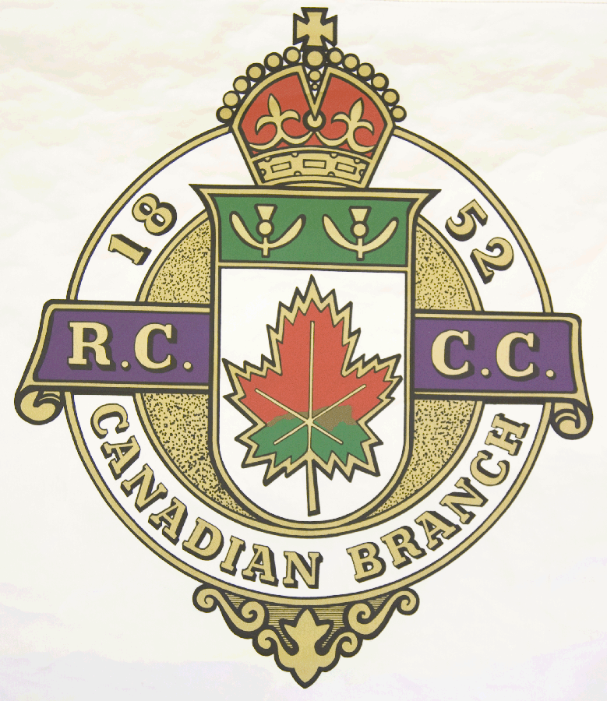
Hosting Club: _ Ormstown Curling Club_____
Host Club Address: _ 7 Chateauguay _____
Host Club City: _ Ormstown, Qc._____________

Host Club Telephone: (450) 829 – 2855

Host Contact Person: Bill Stevenson
Contact phone or email : (450) 827 – 2461

Hosting Club: Ormstown Challenging Club: Cornwall

Skip: Scott Hill Skip: Matt Camm

Third: Scott McClintock Third: Matt Dupuis

Second: Louis Rollin Second: Terry Lichty

Lead: Frank Rollin Lead: John Wright

Skip: Jack Lamb Skip: Kevin Baker

Third: Chris Rember Third: Scott McDonald

Second: Trevor Lamb Second: Jeff Bethurie

Lead: Jason Schink Lead: Robert Mahon

 | Skip | 1 | 2 | 3 | 4 | 5 | 6 | 7 | 8 | 9 | 10 | Score
Sheet 1 | S. Hill | 2 | 2 | 1 | 3 | 0 | 1 | 0 | 1 | 0 | X | 10
Sheet 1 | M. Camm | 0 | 0 | 0 | 0 | 4 | 0 | 2 | 0 | 2 | X | 8
Sheet 2 | J. Lamb | 0 | 1 | 0 | 0 | 1 | 1 | 0 | 0 | 1 | 0 | 4
Sheet 2 | K. Baker | 2 | 0 | 3 | 2 | 0 | 0 | 2 | 2 | 0 | 1 | 12

Hosting club Score: 14 Challenging club score: 20

Note: Description of the game should follow on separate page as well as photos of the teams.

